Whole Class Readers 2024-2025
 | Autumn 1 | Autumn 2 | Spring 1 | Spring 2 | Summer 1 | Summer 2
Year 2 | A Necklace Of Raindrops Joan Aiken and Jan Pienkowski  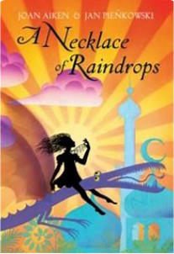 | Owen and the Soldier: Lisa Thompson  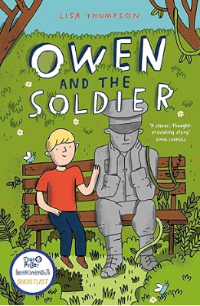 | Pippi Longstocking by Lauren CHild  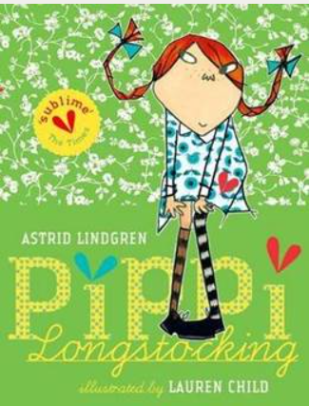 | Charlie and the Chocolate Factory Roald Dahl  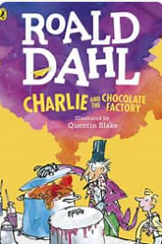 | The Boy Who Drew Dragons  Andy Shephard  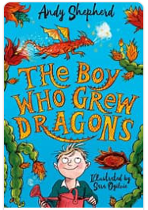 | Mr Penguin and the Lost Treasure  Alex T Smith  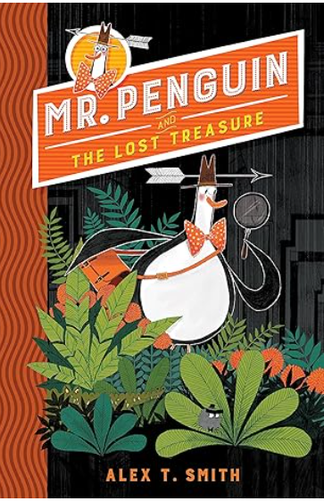
Year 3 | Charlotte’s Web EB White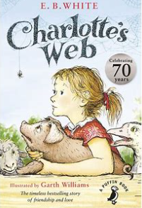 | The Iron Man Ted Hughes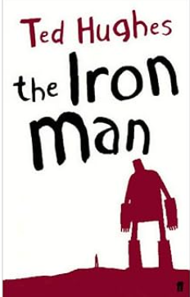 | Hannah Gold The Last Bear   | The Lion, The Witch and the Wardrobe CS Lewis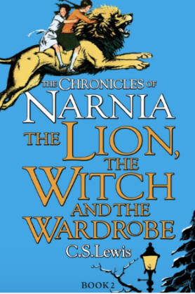 | 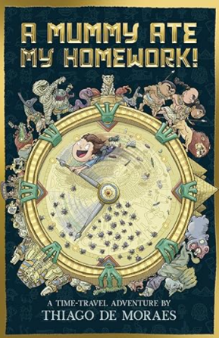  A Mummy Ate my Homework by Thiago de Morales | Theres An Alien in the Jam Factory by Chrissie Sains  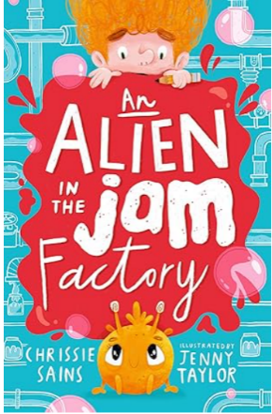
Year 4 | The BFG Roald Dahl  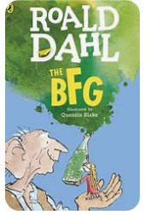 | 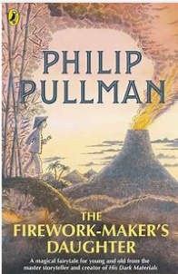  The Firework Maker’s Daughter Philip Pullman | The Boy at the Back of the Class  Onjali Q Rauf  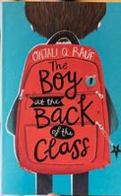 | How to Train Your Dragon by Cressida Cowell  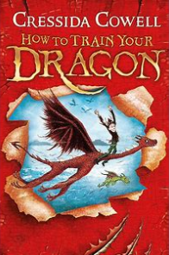 | The Train to Impossible Places PG Bell  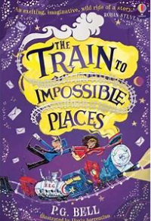 | Varjack Paw SF Said  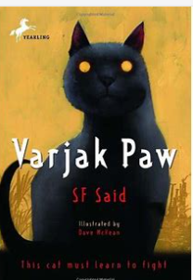
Year 5 | Anglo-Saxon Boy Tony Bradman  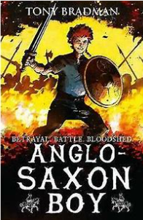 | No Ballet Shoes in Syria by Catherine Bruton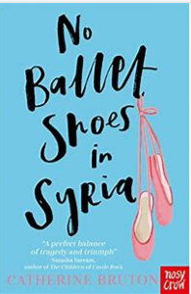 | The Explorers  Katherine RUndell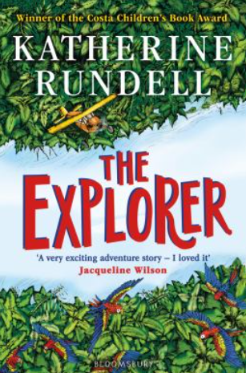 | Kick Mitch Johnson 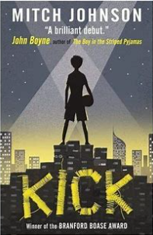 | Kensuke’s Kingdom Michael Morpurgo  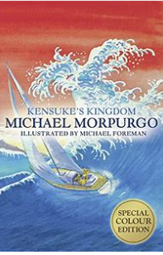 | 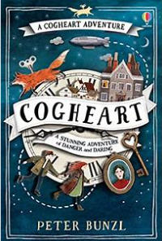  Cogheart Peter Bunzl
Year 6 | War Horse Michael Morpurgo  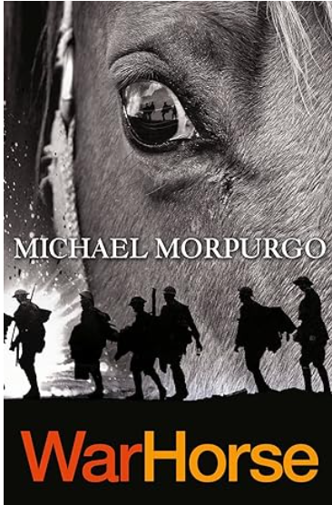 | Skellig David Almond  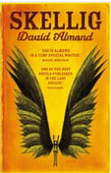  The Final Year Matt Goodfellow | 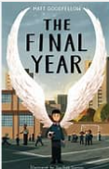  Holes Louis Sachar | When the Sky Falls Phil Earle  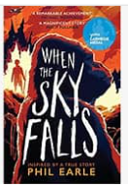 | Can You See Me? Libby Scott  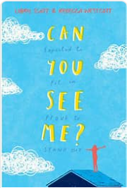 | Little Badman and the Invasion of the Killer Aunties Humza Arshad  