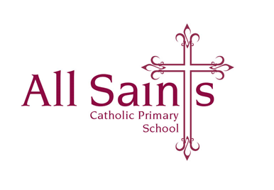Cedar Road

Ashton-Upon-Mersey

Sale M33 5NW

Tel No: 0161 962 1288

Fax No: 0161 962 1887

Email: admin@allsaints.trafford.sch.uk

Website: [www.allsaints.trafford.sch.uk](http://www.allsaints.trafford.sch.uk)

Headteacher: Mrs AC Fagan MA NPQ

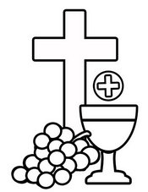 SACRAMENTAL PROGRAMME 2025 [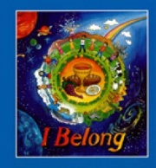](http://www.google.co.uk/url?sa=i&rct=j&q=&esrc=s&source=images&cd=&cad=rja&uact=8&ved=0CAcQjRxqFQoTCP_7gI6H08gCFUe0FAodSggANg&url=http://www.rpbooks.co.uk/products/12/1051/sacraments/i-belong-childrens-book&bvm=bv.105454873,d.d24&psig=AFQjCNFf8JbI8E219amhHzyqgoDdY9cN3g&ust=1445499414424557)

Dear Families,

If you would like your child to participate in the preparation and receiving of both their First Forgiveness and First Holy Communion, Father Ned has asked that proof of a Catholic Baptism must be shown before your child starts the programme. **Please bring your child’s Catholic Baptism certificate to the school office by Monday 21st October.** If you think we have your child’s certificate on file already, please speak to the office to confirm your child’s place.

If you have any questions about your child’s baptism certificate, please contact Fr Ned.

Many thanks,

Mrs Alicia Murphy

RE Lead