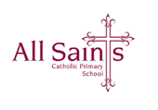

Dear Families,

**First Holy Communion Mass- Saturday 17th May, All Saints’ Church at 10am**

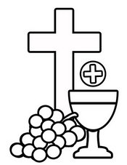

On the day of your child’s First Holy Communion, please drop your child off at school 45 minutes before Mass starts, where they will be welcomed at the door by a member of staff. Children should arrive at school at **9.15am.** Parents do not need to wait with their children. Individual and class photographs will be taken by the hired photographer.

The children will process into Church for the Mass at 10 am. They will process onto the altar and then go to sit with their families. A bench will be reserved for each family. Other members of your group should arrive early to get a seat elsewhere in Church.

During Holy Communion time, the children will be invited, with their immediate family, to receive The Holy Eucharist in their hands. Staff will be on hand to guide and assist during this time.

Fr Ned requested that **no photos or videos be taken at any point during the Mass**. Please ensure that family members are aware of this and that no one should leave their seat to take photos.

Readings, bidding prayers etc will be allocated to older siblings. Please let me know ASAP if a sibling would like to take part in the service. I will send the readings home with the children-Thank you!

The offertory collection will be for the With Love, Steph Foundation.

At the end of the service the children will process out of the Church together. Please collect your child from the outside area of Church as soon as the Mass has ended- Thank you!

**Presentation to the Parish Mass and Collection of Certificates- Sunday 18th May, All Saints’ Church at 9:30am**

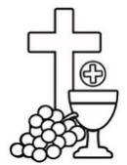Another opportunity to wear their Communion outfits! The children will receive their Holy Communion certificate on this date.

**Holy Communion School Celebration Mass- Thursday 22nd May, at All Saints’ Church at 9.30 am**

Children should arrive in school in their Communion outfits. They should have their school uniform to change into, later. After Mass, there will be a short service to crown Our Lady, which will take place in the prayer garden (weather permitting). Families are invited to join us for the Mass and Crowning and to then join the children in school for a short Holy Communion celebration.

If you have any questions, please do not hesitate to contact member of staff. Thank you for your continuing support.

Mrs Murphy, Mrs Ostmeier and Miss Meehan

‘You can do things I cannot, I can do things you cannot, together we can do great things’ –

Mother Teresa