

**All Saints’ Catholic Primary School**

**Sports Premium Report 2018-2019**

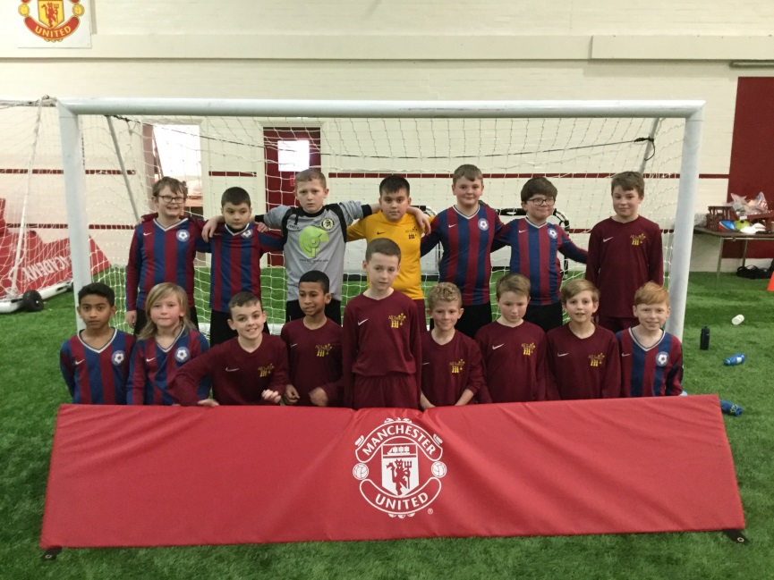

**Sports Premium 2018-2019**

At All Saints’ we believe that a high-quality physical education curriculum inspires all pupils to succeed and excel in competitive sport and other physically-demanding activities. We provide opportunities for pupils to become physically confident in a way which supports their health and fitness. We know that opportunities to compete in sport and other activities build character and help to embed values such as fairness and respect.

Aims

• develop competence to excel in a broad range of physical activities

• are physically active for sustained periods of time

• engage in competitive sports and activities

• lead healthy, active lives

There are 5 key indicators that schools should expect to see improvement across.

**Key indicator 1:** The engagement of all pupils in regular physical activity – Chief Medical Officer guide lines recommend that primary school children undertake at least 30 minutes of physical activity a day in school.

**Key indicator 2:** The profile of PE and sport being raised across the school as a tool for whole school improvement.

**Key indicator 3**: Increased confidence, knowledge and skills of all staff in teaching PE and sport.

**Key indicator 4:** Broader experience of a range of sports and activities offered to all pupils.

**Key indicator 5:** Increased participation in competitive sport.

**This year, All Saints’ will receive £17776 of Sports Premium funding.**

**National Curriculum Swimming and Water Safety Requirements.**

|  |  |
| --- | --- |
| What percentage of your current Year 6 cohort swim competently, confidently and proficiently over a distance of at least 25 metres? | 100% |
| What percentage of your current Year 6 cohort use a range of strokes effectively (eg front crawl/backstroke/breaststroke)? | 93% |
| What percentage of your current Year 6 cohort perform safe self-rescue in different water-based situations? | 80% |

|  |  |  |  |
| --- | --- | --- | --- |
| **Spending** | **Impact** | **Cost** | **Next steps/sustainability** |
| We have paid for a company to provide PE from a specialist sports coach for our children once a week. Teachers have access to an app to aid planning and assessment. | * Children benefit from teachers’ use of the app to ensure continuity across key stages teaching of PE and assessment. * Staff have a selection of P.E. schemes to choose from which can be linked into the topics being taught that term. * Coaches offer a variety of before and afterschool clubs for our children. * Experienced and trained coaches are responsible for children’s P.E. lessons once a week. | £7600 | * Children benefit from lessons taught by specialist coach and the skills are transferrable as they move through school. * Children are exposed to a variety of aspects of PE as the app supports staff when implementing an area of PE that may not have been taught before. * Children have access to many different before and after school clubs. |
| Coaches from the Manchester United Foundation teach every child over the course of a year. | * Ensures quality coaching of movement skills across all key stages. * Professional development of staff who participate in lessons too. * Subsidised after school club for all children. * Opportunities for children which reward, boost confidence and self-esteem, link the curriculum to football. * (Christmas party, Referees escort, tour of ground and museum, football tournaments) * Professional coaches to provide girls only football sessions for Y5/6 to increase confidence of girls of this age with expert coaching. | £3500 | * Children benefit from lessons taught by specialist coach and the skills are transferrable as they move through school. * Teachers must attend these sessions and benefit from CPD whilst watching and speaking to the coach. This can be used in future lessons in any are of P.E. * Being linked with Manchester United helps to raise the profile of PE in our school. |
| Trafford Schools Sports Partnership | * As a school we can access cheaper/free training for staff. * All Saints have free entry to all Trafford Sports Competitions. * Support for P.E. coordinator at termly network meetings * Training for Y5 children to become play leaders. * The PE coordinator is kept up to date with new initiatives with new initiatives which will benefit the school. | £600 | * We have accessed training such as playground leader training for our Y5 children. This gives them a position of responsibility within school. * Children are given invaluable experiences whether competing in competitions or participating in festivals. They develop more confidence and self-esteem from representing their school. * PE coordinator is able to feedback and implement any new initiatives in school ie Daily Mile. |
| Transport | * Mini bus to Old Trafford for the Manchester United Christmas party. | £43 | * Confidence gained through representing the school. |
| Commando Joe | * It is expected that this alternative approach to the curriculum will inspire teachers with the delivery of the curriculum. * Pupils will be participating in new and interesting activities encouraging perseverance, resilience and team work. * This enables children to be more physically active in all areas for the curriculum. * Children who find it difficult to sit still when they learning will be much more able to remain focused when accessing the curriculum. | £1475 | * Staff will be undertaking additional training before programme is implemented in school. * More training to be undertaken by staff before this will be delivered in school. * Staff will be looking out for differences in concentration and behaviour. |
| OAA training specialist came to support staff with ideas for OAA activities. | * Staff given ideas to develop with their classes and are more confident when teaching OAA. | £100 | * Members of staff are equipped with skills and ideas to put into practise when they next teach this unit. * Skills are transferrable to future years and others areas of the curriculum. |
| Redevelopment of outdoor space, long term project to include a MUGA on the KS2 playground, daily mile track on the school field and alterations to the EYFS play area. | * Improvement to outdoor learning, enabling games to be played in all weathers, purposeful area for football/ hockey/netball keeping the remainder of the playground safer from disturbances from ball etc. Improvement to outdoor learning experience during PE lessons as well as during playtimes. * Enabling all children to take part in the daily mile in all weathers. Contributing to healthier lifestyles and fighting obesity. * Alterations to the EYFS area, creating a safer all weather area encouraging creativity and imagination. | £20 000 (monies from this year to be rolled over to help cover costings) | * Continue to use sports grant along with contributions from FoAS to help develop the important outdoor learning areas to provide quality learning experiences in all weathers. * To redevelop and improve the aesthetics of the outdoor area. |