

**All Saints’ Catholic Primary School**

**Sports Premium Report 2021-2022**

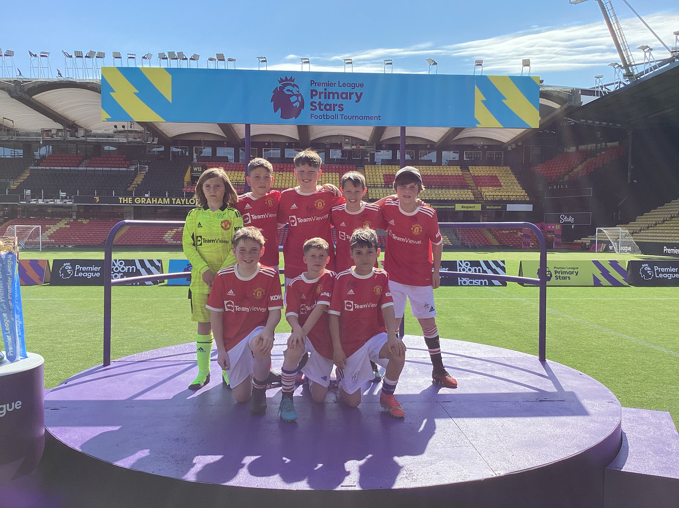

**Sports Premium 2021-2022**

At All Saints’ we believe that a high-quality physical education curriculum inspires all pupils to succeed and excel in competitive sport and other physically-demanding activities. We provide opportunities for pupils to become physically confident in a way which supports their health and fitness. We know that opportunities to compete in sport and other activities build character and help to embed values such as fairness and respect.

Aims

• develop competence to excel in a broad range of physical activities

• are physically active for sustained periods of time

• engage in competitive sports and activities

• lead healthy, active lives

There are 5 key indicators that schools should expect to see improvement across.

**Key indicator 1:** The engagement of all pupils in regular physical activity – Chief Medical Officer guide lines recommend that primary school children undertake at least 30 minutes of physical activity a day in school.

**Key indicator 2:** The profile of PE and sport being raised across the school as a tool for whole school improvement.

**Key indicator 3**: Increased confidence, knowledge and skills of all staff in teaching PE and sport.

**Key indicator 4:** Broader experience of a range of sports and activities offered to all pupils.

**Key indicator 5:** Increased participation in competitive sport.

**This year, All Saints’ will receive £17,776 of Sports Premium funding.**

**£11470.35**

**Extra spent -**

**National Curriculum Swimming and Water Safety Requirements.**

|  |  |
| --- | --- |
| What percentage of your current Year 6 cohort swim competently, confidently and proficiently over a distance of at least 25 metres? | 94% |
| What percentage of your current Year 6 cohort use a range of strokes effectively (for example, front crawl, back stroke and breast stroke? | 85% |
| What percentage of your current Year 6 cohort perform safe self rescue in water based situations? | 76% |

|  |  |  |  |  |
| --- | --- | --- | --- | --- |
| **Spending** | **Cost** | **Intent and Implementation** | **Impact** | **Next steps/sustainability** |
| Sale Sport’s Club Coaching | **£7,700** | **Key indicator 1, 2, 4, 5:** The profile of PE and sport being raised across the school as a tool for whole school improvement. | Variety of afterschool clubs for children at school, consistency with the teaching of PE at our school. | When clubs which are popular, enter competitions for these children to represent school. |
| Get Set 4 PE | £550 | **Key indicator 2, 3**: Increased confidence, knowledge and skills of all staff in teaching PE and sport. | Staff feel more confident and equipped to take PE lessons. Clear progression through year groups. | Look at building own curriculum through additional staff training. |
| Transport and Staffing for Sporting venues | £1620 | To allow children to participate in competitions. To build children’s confidence, to boost self-esteem.  **Key indicator 2,4,5:**  Y4 – multi skills  Coach to Cliff x4  Coach to Etihad x3  Watford supply 2 days | Due to the successes of our football teams (boys and girls) we are seeing more children wanting to take part in the league matches at Crossford bridge and attending our after-school football clubs.  Y4 class participated in sports festival at Brooklands. It was the first chance that these children have had to represent our school and they were able to try a selection of activities during the afternoon. | To all those who want, to participate in competitive games.  To arrange extra games with local schools.  To have house competitions in school. |
| Play equipment | £666.42 | **Key indicator 1:**  Tennis balls differentiated, nets, kwik cricket set, footballs, basketballs, skipping ropes, tennis balls, plastic tennis rackets, bats, ball pumps, | More children were kept active at break times. There is still the problem of children not looking after the equipment as they should. | Play equipment is not being properly looked after and we are looking at something more permanent for keeping children active at break times. |
| Membership to Trafford School Sports Partnership | £550 | **Key indicator 3, 4, 5**  To offer staff training and allow children access to competitions and festivals | Children continue to represent All Saints’ in competitions and we have begun to enter more festivals. | To continue to build on our successes of children entering competitions and festivals. |
| African drums | £42 | **Key indicator 2,4:**  To allow children the opportunity to experience a variety of sporting activities. | The children were given the chance to play African drums and experience dance from another culture. | To invite other experts into school each year for children to experience different types of physical activities. (Drumba) |
| Trophies for Y5 Boys | £21.93 | **Key Indicator 5:**  To encourage children to volunteer to represent their school in competitions. All members of the winning team will receive a trophy/medal. | More children are wanting to represent school. Their confidence has increased as a result. | For children to receive badges when they have represented their school in competitive sport. |
| Develop playground for break times | £8000 | **Key Indicator 1:**  To provide more sturdy equipment for children to use to encourage physical activity at break time. A new area will be created in the playground for KS2 children to use. | To be completed next year. | Providing variety of different equipment to compliment the new area. |
| Bite Size Bootcamp | £320 | **Key Indicator: 1,2,4**:  To improve children’s well- being, increase confidence, raise the profile of P.E. and the importance of physical activity in everyday life. | All children had a great time. Parents commented on how the children had been so excited and were saying what a great time was had. The parents were very pleased with the whole event and enjoyed seeing the photos on the school web page. Children who were initially very anxious about trying out some activities, absolutely loved it and tried all the stations. | Due to the success, we have organised another event for May. We hope to encourage the few children who didn’t join in last time to have a go this time. |