

**All Saints’ Catholic Primary School**

**Sports Premium Report 2020-2021**

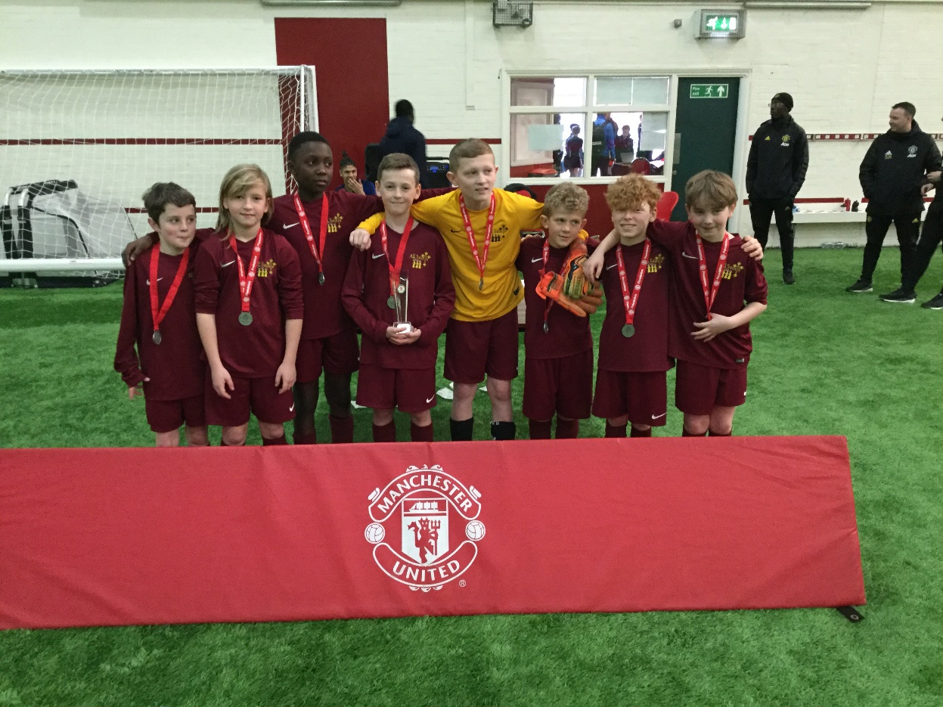

**Sports Premium 2020-2021**

At All Saints’ we believe that a high-quality physical education curriculum inspires all pupils to succeed and excel in competitive sport and other physically-demanding activities. We provide opportunities for pupils to become physically confident in a way which supports their health and fitness. We know that opportunities to compete in sport and other activities build character and help to embed values such as fairness and respect.

Aims

• develop competence to excel in a broad range of physical activities

• are physically active for sustained periods of time

• engage in competitive sports and activities

• lead healthy, active lives

There are 5 key indicators that schools should expect to see improvement across.

**Key indicator 1:** The engagement of all pupils in regular physical activity – Chief Medical Officer guide lines recommend that primary school children undertake at least 30 minutes of physical activity a day in school.

**Key indicator 2:** The profile of PE and sport being raised across the school as a tool for whole school improvement.

**Key indicator 3**: Increased confidence, knowledge and skills of all staff in teaching PE and sport.

**Key indicator 4:** Broader experience of a range of sports and activities offered to all pupils.

**Key indicator 5:** Increased participation in competitive sport.

**This year, All Saints’ will receive £ of Sports Premium funding. £17, 776**

**Total spent so far: - £27,614.63**

**Extra spent £9,838.63**

**National Curriculum Swimming and Water Safety Requirements.**

|  |  |
| --- | --- |
| What percentage of your current Year 6 cohort swim competently, confidently and proficiently over a distance of at least 25 metres? | 92% |
| What percentage of your current Year 6 cohort use a range of strokes effectively (for example, front crawl, back stroke and breast stroke? | 85% |
| What percentage of your current Year 6 cohort perform safe self rescue in water based situations? | 70% |

|  |  |  |  |  |
| --- | --- | --- | --- | --- |
| **Spending** | **Funding Allocation** | **Intent and Implementation** | **Impact** | **Next steps/sustainability** |
| Sale Sports Club | £4494 | Qualified sports coach to deliver a varied curriculum session of P.E. a week for each teacher Y1-6. To also identify which sports are popular and to deliver these sports via after school clubs.  (K.I. 3,4) | Having a regular coach who is so involved in our school has ensured greater discipline during PE lessons. Children want to do well and enjoy these lessons. As a result, we have more children wanting to attend after school clubs run by the coach. | Coach to support with refreshing teachers knowledge and ideas during PE lessons. |
| Play equipment | Baskets for storage, skipping ropes, tennis balls, balancing footbridge, French skipping, ball pumps, stilts, cricket kits x 4, footballs, play bats, tennis rackets  £919 | To supply sustainable equipment and storage for children to use at playtimes in order to participate in active breaktimes. Storage has been given to classes in order for them to have ownership and responsibility for their equipment.  Baskets have been ordered for Y6 and 2 to trial. It is hoped that these will allow any wet equipment to dry and therefore increase longevity.  (K.I. 1,) | Less children participating in each group so more children have the chance to trial different equipment and activities.  Less arguing over equipment.  Children being more active at break times. | To ‘top up’ as and when necessary. |
| Review of PE equipment to support quality delivery | Tennis nets and tennis balls £121.63 | Update equipment for tennis lessons, to make equipment more user friendly for teachers and use of different tennis balls to allow for differentiation.  (K.I.2,4) | Those children who weren’t as confident in tennis were able to practise their skills with appropriate equipment resulting in higher quality learning. | Purchase new tennis rackets. |
| Decathlon vouchers | £85 | To encourage involvement of physical activity during lockdown. Walking challenge for all children and prizes given to those who complete the most miles/steps.  (K.I.1,2,5) | Pictures were sent in of children out enjoying their walks. Winners announced in assembly via Zoom. | To hold a similar competition again next year. |
| Cross Curricular Orienteering | £1700 | To create a sustainable orienteering course for PE and other subjects. To encourage more outdoor lessons. The course will be set up by the company who will deliver staff training on that day.  (K.I. 2,3) | To provide all children with quality, varied OAA lessons. For staff to receive training for using this course and resources leading to higher quality learning. | This course will be able to be used by all year groups as they move through their school years. We will look into developing this for KS1 when available. |
| Field make over | £20000 | (K.I.1,4) | This was delayed due to Covid. | To keep children active during break times and to make more use of the school field, increasing physical activity. |
| Bite sized Bootcamp | £484 | To welcome children back to school  (K.I.2,4) | All children had a great time. Parents commented on how the children had been so excited and were saying what a great time was had. The parents were very pleased with the whole event and enjoyed seeing the photos on the school web page. Children who were initially very anxious about trying out some activities, absolutely loved it and tried all the stations. | Due to the success, we organised another event for May. All children showed more confidence during the completion of the course and weren’t afraid to have a go.  We have also arranged for Boot Camp sessions for KS1 and KS2 as before and after school sessions. These are very popular amongst all ages. |
| Skipping workshop | £295 | To improve children’s well- being, increase confidence, raise the profile of P.E.  (K.I. 1,4) | Children bought and used ropes at break times, increasing their levels of activity at home and school. |  |