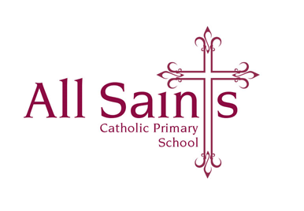

Thursday 7th September 2024

Dear Parents and Carers,

**Welcome Back!**

I hope you’ve all had a fantastic summer and made some precious memories!

We’ve had a wonderful time this week, I can’t wait to get to know the children as the weeks go on.

Just a couple of things for you to note:

* Our **Class Reader** for the first term will be the classic story **Charlotte’s Web by E. B. White**; if any of the children have a copy of this at home could they please bring it into school, however I do have enough copies for one between two so there is no need to buy one if they don’t have a copy.
* Our Year 3 Welcome Meeting **Monday 18th September at 3:30pm**. Children will be looked after in another classroom. Please don’t worry if you can’t make this meeting, I will summarise the key points and send them out in a letter/power-point.
* **PE** will be on a **Wednesday and Thursday**; children can come to school in their PE lit on these days.
* Please ensure water-bottles and uniform are labelled with children’s names.
* **Parent Planners** will go home on Friday and will be on our Class Page on the school website soon.
* **Homework**: English will be given out on a Friday for a Monday/Tuesday and Maths will be given out on a Wednesday to be returned the following Friday/Monday.
* **Spellings** for the term are on a sheet inside the children’s homework books, I will send out an additional copy for you to keep at home**.** Further detail is on the sheet itself.
* Please can the children have their **reading books** in their bags everyday.

Please don’t hesitate to come and see me before or after school with any questions whatsoever.

Wishing you all a wonderful weekend enjoying the sunshine and I really look forward to seeing the children on Monday!

Many thanks,

*Mrs O’Dwyer*