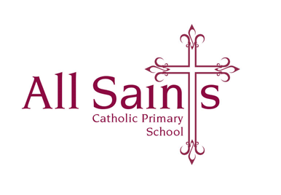

Friday 3rd November 2023

Dear Parents and Carers,

I hope you all have had a lovely half term break? We have certainly had a fabulous first week back!

A few notices:

* Parent Planners have been e mailed home and a copy can be found on the Class Page on the school website.
* Spellings were sent home on Monday and I have also put a copy in their English homework books; they can also be found on the school website.
* Our Mini Vinnies are collecting any old hats, scarves and gloves for a local homeless charity. The next collection for any of these unwanted items will be next Thursday 9th November.
* PE will continue to be on a Wednesday and Thursday (unless I send a text saying otherwise) children can come to school in their PE kit on these days.
* Homework will continue to be English given out on a Friday for a Monday/Tuesday and Maths to be given out on a Wednesday and returned the following Friday/Monday.

As always thank you so much for all your support, I really do appreciate it. Please don’t hesitate to come and see me before or after school with any questions whatsoever.

Have a lovely weekend!

Many thanks,

*Mrs O’Dwyer*