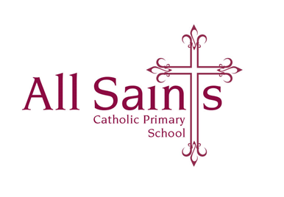

Friday 23rd February 2024

Dear Parents and Carers,

I hope you all have had a lovely half term break? We have certainly had a fabulous first week back!

A few notices:

* **Parent Planners** have been e mailed home and a copy can be found on the Class Page on the school website.
* **Spellings** have been sent home today and can be found in their English homework books (test every Friday); they can also be found on the school website.
* **PE** will continue to be on a Tuesday and Friday (unless I send a text saying otherwise). Children can come to school in their PE kit on these days.
* **Homework** will continue to be English given out on a Friday for a Monday/Tuesday and Maths to be given out on a Wednesday and returned the following Friday/Monday.
* **First Forgiveness** Thursday 29th February at 6pm in church for those children who are making their First Holy Communion.
* **Sacramental Meeting -** Mondays 3:20pm – 4:15pm
* Can all children please have both their school **reading book** and reading record available in their school bags every day. Please encourage the children to read every night and fill in their reading record accordingly.

Furthermore, as Mrs Sweeney will now be teaching Year 5 until the end of the academic year, we are delighted that Mrs Ostmeier will be teaching our wonderful Year 3 children on a Wednesday morning.

As always thank you so much for all your support, I really do appreciate it. Please don’t hesitate to come and see me before or after school with any questions whatsoever.

Have a lovely weekend!

Many thanks,

*Mrs O’Dwyer*