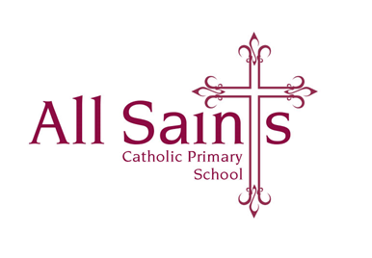

Thursday 12th October 2023

Dear Parents and Carers,

I am sure you will have heard the children mention that we have Mrs Sweeney teaching in Year 3 a morning each week, this is to release me as Deputy Headteacher. Mrs Sweeney has a wealth of teaching experience and retired from All Saints’ a few years ago. Since her retirement she has supported me with my teaching commitment - most recently in Year 6 - this has enabled me commit to my deputy duties. Along with Mrs Moores and Miss Meehan, our fantastic Y3 Teaching Assistants, we have an excellent working relationship and very much look forward to an exciting year with the children.

Apologies that the Class Page on the School website hasn’t been updated yet, we have been waiting on our external provider to archive the old pages. This has just been done so I will begin to update the Year 3 Class Page in the next few days.

I very much look forward to meeting you next week at our Parents’ Evenings.

Please don’t hesitate to come and see me before or after school with any questions whatsoever.

Many thanks,

*Mrs O’Dwyer*