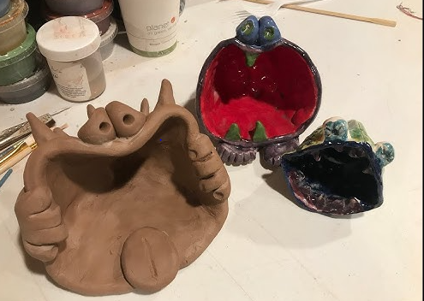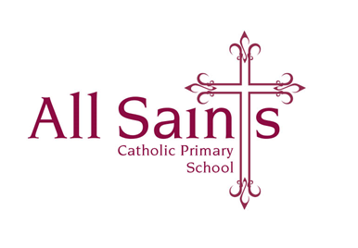

Tuesday 28th November 2023

Dear Parents and Carers,

**Year 3 Art Trip: Wednesday 29th November 2023**

We are very excited to be going on our trip tomorrow; can children please wear their school uniform tomorrow (PE kits on Thursday as usual).

We will eat our lunch a little earlier in school before we go; we will be back at school for our pick-up time of 3:20pm

The cost of the trip is £10 – this is for transport and the art materials; this can be paid via Parent Pay - this is also your consent to your child attending. If you have any problems with this please don’t hesitate to contact me.

As always thank you so much for your support – it is appreciated.

With very many thanks,

*Mrs O’Dwyer*