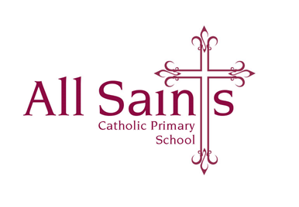

Thursday 7th December 2023

Dear Parents and Carers,

**Friday 8th December 2023**

Just a few notices for Year 3:

**Maths homework**

Times tables Rockstar’s tournament, boys vs girls, will end Friday morning at 8:30am, good luck to both teams.

**Spelling Test**

As usual on Friday morning, spellings are available on the Class Page on the school website, copies were sent home at the beginning of the half term.

**Christmas Fair Cakes**

Children can wear their own clothes tomorrow, Friday, for a small donation of cakes. Our Christmas Fair will be held after school tomorrow in our school hall; please come and support this lovely, festive event.

**Golden Time**

We are very excited to hold a pyjama party tomorrow afternoon. Children can bring their pyjamas/nightwear (with slippers and a dressing gown) to change into at lunchtime. Children can also bring in a teddy OR a cushion OR a small blanket, being mindful of how we will store them in the morning. We will hopefully be watching some of Charlotte’s Web (as long as it has arrived through the post) and enjoying a hot chocolate.

As always, thank you so much for your support – it is appreciated.

With very many thanks,

*Mrs O’Dwyer*

