 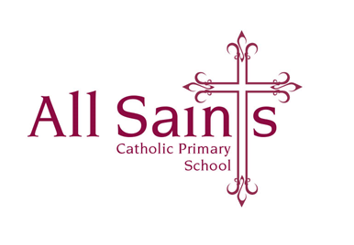

Monday 18th December 2023

Dear Parents and Carers,

**KS2 Advent Service**

**Tuesday 19th December 6pm in Church**

**All children to meet staff in church at 5:50pm**

Please can **Years 3, 5 and 6** children wear their full winter uniform – a white shirt with tie, jumpers not required, for the service tomorrow evening.

Costumes will be sent home with **Year 4** children tomorrow – can they please wear these to church for the service in the evening.

If your child is performing a dance or gymnastics routine in the service, please can they wear all black or their own dance costumes.

We very much look forward to seeing you tomorrow evening.

As always thank you so much for your support – it is appreciated.

*KS2 Staff*