French Year 5 will continue to enjoy French each week with our Foreign Language Assistant Madam Adam extending our conversational French vocabulary.

English We will study the poem, The Dreadful Menace, and use simile and metaphors to create extreme weather warnings. The children will study *Shackleton’s Journey* by William Grill in which children begin by volunteering to join a ‘hazardous journey’. They will then apply for one of the many roles on Shackleton’s expedition. Children then go on to use William Grill’s text to find out about the perilous adventure whilst creating dairy entries in role, and writing both formal and informal letters. Using the text, The Highwayman by Alfred Noyes, children will also write a news report of the event. We will continue to expand our knowledge and understanding of grammar and punctuation covering: conjunctions, commas, inverted commas, using brackets, dashes and commas to indicate parenthesis. Handwriting and spelling will be taught discreetly and practised regularly. Please continue to read widely, but most importantly, daily at home, for pleasure; to build speed, fluency and understanding. Our new whole class reader text will be *The Explorer* by Katherine Rundell.

Geography We will learn all about how the UK is organised into countries, counties and cities, as well as learning about the human and physical features of Great Britain, such as population, life expectancy, tallest mountains, longest rivers, coastlines and much more**.** Children will have a Geography Homework Menu to complete.

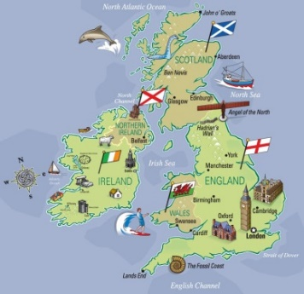

Computing This half term, the children will be learning to write and debug programs using scratch. They will learn to use sequence, selection and repetition in programs. This will involve logical reasoning to explain how simple algorithms work.

Religion In this topic the children will learn about the qualities possessed by followers of Jesus through the theme of Inspirational People. They will be introduced to inspirational followers of Jesus like Oscar Romero and be encouraged to reflect on how they can follow Jesus in their own lives.

Homework The children will be given homework every Friday, the same as last term, and expected to return it on Wednesday. This will involve Maths, English and Spelling. The children should read their school reading book 5 x 20 minutes per week and sign the reading record. They can also have a home reading book of their choice. The children will also continue to learn their times tables.

Art In this topic the children will develop Cityscapes artwork, linked to learning about the UK, after studying city skylines. Using various artistic techniques, including water colour, wax resist and acrylics. They will then plan and create their own cityscape artwork, making decisions about which city they will portray, what styles and techniques they might include and what materials and tools they will need to use.

**Spring 1**

**Year 5**

**Mr Gately**

**2024**



Music As well as regular hymn practices; learning is focused around composition. They will compose and perform, as a class, and their own musical composition. They will create a musical score and how this matches the sounds. As well as learning to sing, play, improvise and compose, children will listen and appraise other songs.

Maths. The children will then learn to multiply and divide numbers mentally drawing upon known facts. Using formal written methods, we will practise multiplying and dividing numbers up to 4 digits by a one or two digit number. We will continue our work on fractions by learning to multiply them. We will also begin learning about decimals, percentages and equivalent fractions. Once mastered, the children will be asked to solve problems involving addition and subtraction, multiplication and division and a combination of these. Maths activities will also be enjoyed outside or on the computer to use Maths in a fun context.

Science

In Science lessons, building on our knowledge of materials, the children will learn about mixtures and solutions. They will study reversible and irreversible changes of materials and will work scientifically to plan and carry out experiments, taking measurements with increasing accuracy and precision. They will interpret data before reporting and presenting their findings.

PSHE This half term we will be looking at what it means to respect a wide range of people, recognizing prejudice and discrimination. We will also be looking at how information is targeted, different media types, their role and impact.

PE This half term Gymnastics lessons will take place on a **Monday** afternoon andOutdoor Adventurous Activities will take place with Mrs Thomson on a **Thursday** afternoon.