Age-related expectations: Reading, EYFS
Non-bold objectives are from Development Matters. Bold objectives are ELGs or aspects of them.
Fluency | Explore and evaluate
- Do I understand that print has meaning?  - Do I understand that print can have different purposes?  - Do I know English is read from left to right and from top to bottom?  - Can I name different parts of a book?  - Do I understand page sequencing?  - Can I spot and suggest rhymes?  - Can I count and clap syllables in a word?  - Can I recognise words with the same initial sound, such as money and mother?  - Can I read individual letters by saying the sounds for them?  - Can I read some letter groups that represent one sound and say sounds for them?  - Can I read some common exception words?  - Can I read some simple phrases and sentences made of words with known letter-sound correspondences and, where necessary, a few exceptions?  - Can I say a sound for each letter in the alphabet?  - Do I know at least 10 digraphs?  - Can I read words consistent with my phonic knowledge by sound blending?  - Can I read aloud simple sentences and books that are consistent with my phonic knowledge, including some common exception words? | - Can I listen attentively and respond to what they hear with relevant questions, comments and actions when being read to and during whole class discussions?  - Can I show my understanding of what has been read to me by retelling stories and narratives using my own words and recently introduced vocabulary?
 | Range
- Can I understand the past through settings, characters and events encountered in books read in class and storytelling?
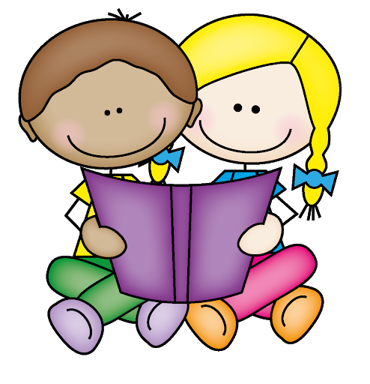
- Can I use and understand recently introduced vocabulary during discussions about stories, non-fiction, rhymes and poems and during role-play?
- Can I listen to rhymes, poems, songs, fiction and non-fiction? (DM)
Retrieve | Vocabulary
 | - Can I use and understand recently introduced vocabulary during discussions about stories, non-fiction, rhymes and poems and during role-play?
Interpret | Oracy/Writing
- Can I anticipate, where appropriate, key events in stories? | - Can I invent, adapt and recount narratives with peers and my teachers?
Choice

Age-related expectations: Reading, Year 1

Fluency | Explore and evaluate
1. Apply phonic knowledge and skills to decode words by responding speedily, matching all 40+ graphemes to their phonemes (Phase 3); where applicable, alternative sounds for graphemes (Phase 5).  2. Apply phonic knowledge and skills to decode words by reading common words using phonic knowledge accurately, blending sounds in unfamiliar words based on known grapheme-phoneme correspondences.  3. Read phonetically decodable texts with confidence and accuracy.  4. Read common exception words (‘tricky words’).  5. Read words of more than one syllable which contain taught grapheme-phoneme correspondences.  6. Read words containing taught grapheme-phoneme correspondences and the following endings: s, es, ing, ed, er, est.  7. Read words with contractions (eg I’m, we’ll); understand apostrophe.  8. Apply phonic knowledge and skills to decode words by responding speedily, matching all 40+ graphemes to their phonemes (Phase 3); where applicable, alternative sounds for graphemes (Phase 5).  9. Recognise and use the repetition of words and rhymes to aid reading.  10. Re-read to build up fluency.  11. Read accurately and confidently words of 2 or more syllables.  12. Understand books (and other texts) they can already read accurately and fluently, and those they listen to.  13. Check that the text makes sense to them as they read and correct miscues, re-reading if necessary. | 19. Understand the difference between fiction and non-fiction.  20. Develop pleasure in reading, motivation to read, vocabulary and understanding.  21. Say what they like or dislike about a text. i  22. Talk about their responses in a group.  23. Listen to and discuss ideas about a text – narrative, non-fiction and poems – including at a level beyond that at which they can read independently.
 | Range
24. Be very familiar with some key stories, including traditional and fairy tales.
25. Experience poems and rhymes.
26. Learn some poems and rhymes by heart.
27. Use context and vocabulary provided to understand texts.
28. Understand and talk about the main characteristics of the key stories known.
29. Use prior knowledge to understand texts.
Retrieve | Vocabulary
12. Talk about the title and the events.  13. Re-tell main events. ii | 30. Discuss and clarify word definitions, linking new meanings to known vocabulary.
Interpret | Writing
14. Make predictions based on the events in the text. ii  15. Begin to draw inferences from the text and / or the illustrations. ii  16. Explain what they understand about a text.  17. Link what they read or hear read to their own experiences to support inference and empathy, for example. | 31. Begin to use punctuation to vary pace and expression when reading aloud eg pauses at full stops, asks questions with different intonation.  32. Identify narrative language.  33. Retell key stories orally using narrative language.
Choice
18. Answer and ask appropriate questions about writer’s choice (eg Why has the author used the word ‘heave’?)

Age-related expectations: Reading, Year 2

Fluency | Explore and evaluate
1. Apply phonic knowledge and skills to decode words by blending the sounds in words that contain the graphemes taught.  2. Apply phonic knowledge and skills to decode words by recognising and reading alternative sounds for graphemes.  3. Apply phonic knowledge and skills to decode words by reading accurately words of two or more syllables that contain the same GPCs as above.  4. Decode automatically and fluently: read most (93% - 95%+) words quickly and accurately when they have been frequently encountered without overt sounding and blending.  5. Read words containing common suffixes.  6. Read further common exception words.  7. Read and notice unusual correspondence between grapheme and phoneme (eg wash, jealous).  8. Read aloud books (and other texts) closely matched to their improving phonic knowledge, sounding out unfamiliar words accurately, automatically and without undue hesitation.  9. Read these books (and other texts) fluently and confidently, possibly by re-reading to build up this skill.  10. Understand both the books / texts that they can read accurately and fluently and those they listen to.  11. Read for meaning, checking that the text makes sense and correcting inaccurate reading. | 20. Explain and discuss understanding of books, poems and other material, both those read aloud and those read independently.  21. Be aware that non-fiction books (and other texts) are structured in different ways.  22. Develop pleasure in reading, motivation to read, vocabulary and understanding.  23. Discuss books, poems and other works that are read aloud and independently, expressing opinions and listening to others’ opinions (eg plot, settings, characters).  24. Listen and respond to (by discussing and expressing views) a wide range of poetry (including contemporary and classic), stories and non-fiction at a level beyond that at which they can read independently.  25. Use prior knowledge, context and vocabulary explored to understand texts.  26. Talk about favourite words and phrases.
 | Range
27.Increase repertoire of poems learnt by heart, appreciating these and reciting some, with appropriate intonation to make the meaning clear
28. Become increasingly familiar with a wider range of stories, fairy stories, traditional tales and non-fiction.
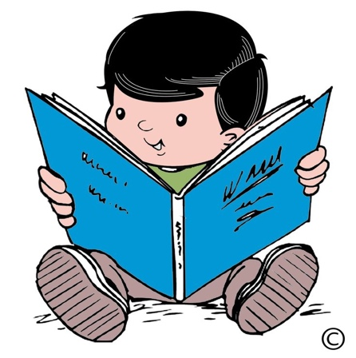

Retrieve | Vocabulary
12. Locate information using contents and index.  13. Recounts main themes and events by showing understanding of the main points of the text.  14. Answer appropriate questions about events and characters. | 29. Discuss and clarify word definitions, linking new meanings to known vocabulary.
Interpret | Writing
15. Ask appropriate questions about events, inferred events and characters.  16. Draw simple inferences from illustrations and text on the basis of events, character’s actions and speech.  17. Make predictions on the basis of what has been read so far.  18. Answer appropriate questions about inferred events and characters. | 30. Discuss the sequence of events in books (and other texts) and how items of information are related.  31.Make links between spellings, punctuation and grammar that has been taught  32. Use punctuation to vary pace (eg pauses appropriately at full stops and commas).  33. Retell orally key stories (a range, including fairy stories and traditional tales) using narrative language.  34. Begin to use punctuation to vary expression (eg questions with different intonation or character voices). 35. Know and recognise simple recurring literary language in stories and poetry.
Choice
19. Answer and ask appropriate questions about writer’s choice (eg Why has the author used the word ‘heave’?)

Age-related expectations: Reading, Year 3

Fluency | Explore and evaluate
1. Can fluently read a set text appropriate for their age.  2. Apply phonic knowledge and skills to read unfamiliar words.  3. Apply knowledge of root words, prefixes and suffixes to read aloud and to understand meaning of unfamiliar words.  4. Read further exception words, noting the unusual correspondences between spelling and sound, and where these occur in the word.  5. Attempt pronunciation of unfamiliar words drawing on prior knowledge of similar looking words.  6. Read aloud with intonation, tone, volume to show awareness of characters’ speech and punctuation. | 14. Understand what they read in books (and other texts) independently, checking that the text is meaningful.  15. Ask questions to improve understanding of a text.  16. Identify how structure and presentation contribute to the meaning of texts  17. Begin to understand that narrative books are structured in different ways (eg quest stories and stories with dilemmas).  18. Make links between spellings, punctuation and grammar that has been taught.  19. Explain and discuss books, poems and other works that are read aloud and independently, taking turns and listening to others’ opinions.  20. Begin to express opinions about how narrative books can be structured (eg quest stories and stories with dilemmas).  21. Develop pleasure in reading, motivation to read, vocabulary and understanding.  22. Begin to recognise themes / ideas in text types covered.
Retrieve | Range
7. Retrieve and record information from fiction and non-fiction.   | 23. Experience and discuss a range of fiction, poetry, plays, non-fiction and reference books or textbooks.  24. Know a wider range of stories, including fairy stories and legends.  25. Begin to recognise some different forms of poetry – list poems, shape poems, free verse etc.  26. Prepare poems and scripts to read aloud and to perform, showing understanding through intonation, tone, volume and action  27. Use dictionaries to check the meaning of unfamiliar words.  28. Choose books (and other texts) for specific purposes.  29. Explain and discuss understanding of books, poems and other material, both those read aloud and independently.
Interpret | Vocabulary
8. Draw inferences such as inferring characters' feelings, thoughts and motives from their actions, beginning to justify these inferences with evidence (eg how characters relate to each other).  9. Predict what might happen from details stated and implied.  10. Know which words are essential to retain meaning in order to begin to summarise.  11. Show an awareness of figurative language. | 30. Explain the meaning of words in context.
Choice | Writing
12. Discuss and record words and phrases that writers use to engage and impact on the reader (eg What choice of verb has been used?).  13. Begin to realise that literary conventions in text types can influence a writer’s choice / style. | 31. Begin to recognise some of the literary conventions in text types covered.  32. Know that non-fiction books / other texts are structured in different ways and be able to use them effectively.  33. Orally re-tell some known stories.  34. Prepare poems and scripts to read aloud and to perform, showing understanding through intonation, tone, volume and action.

Age-related expectations: Reading, Year 4

Fluency | Explore and evaluate
- Can fluently read a set text appropriate for their age.  - Apply phonic knowledge and skills to read unfamiliar words.  - Apply knowledge of root words, prefixes and suffixes (see National Curriculum, Appendix 1, Y3,4 list) to read aloud and to understand the meaning of unfamiliar words.  - Apply knowledge of morphology and etymology to read and understand words.  - Read further exception words, noting the unusual correspondences between spelling and sound, and where these occur in the word.  6. Attempt pronunciation of unfamiliar words drawing on prior knowledge of similar looking words.  7. Read aloud with intonation, tone, volume to show awareness of characters’ speech, punctuation and some grammatical features (eg an embedded subordinate clause).  8. Check the text is meaningful. | 15. Identify and summarise main ideas / theme of a text (more than one paragraph).  16. Ask questions to improve understanding of a text.  17. Know non-fiction books / texts are structured in different ways and be able to use them effectively.  18. Know and recognise some of the literary conventions in text types covered.  19. Know and recognise themes in text types covered.  20. Discuss texts that are read aloud and independently, explaining and listening to ideas and opinions, giving reasons.  21. Develop pleasure in reading, motivation to read, vocabulary and understanding.  22. Begin to build on others’ ideas and opinions about a text in discussion.  23. Make connections between other similar texts, prior knowledge and experience.
Retrieve | Range
9. Retrieve and record information from non-fiction by beginning to skim and scan.  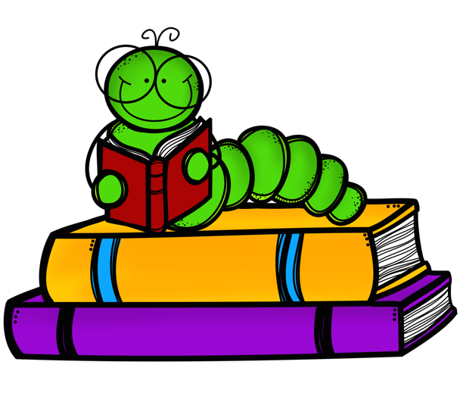 | 24. Use dictionaries to check the meaning of unfamiliar words.  25. Know which books (and other texts) to select for specific purposes, especially in relation to science, history and geography learning.  26. Experience and discuss a range of fiction, poetry, plays, non-fiction and reference / textbooks.  27. Know a wider range of stories, including fairy stories, traditional tales and myths.  28. Recognise some different forms of poetry – list poems, free verse, rhyming verse, etc.  29. Read aloud and perform poems and scripts, showing understanding through intonation, tone, volume and action.
Interpret | Vocabulary
10. Infer meanings and justify them with evidence from the text eg inferring characters’ feelings, thoughts and motives from their actions.  11. Begins to explain the (non-literal) meaning of words in context (eg ‘My heart raced’), including figurative language.  12. Predict what might happen from details stated and implied (deduced information). | 30. Explain the meaning of words in context.
Choice | Writing
13. Discuss and record words and phrases that writers use to engage and impact on the reader, explaining the effect they have.  14. Show understanding that literary conventions in text types can influence a writer’s choice / style. | 31. Identify some text type language features eg narrative, explanation, persuasion.  32. Know non-fiction books / texts are structured in different ways, identifying and using these organisational features effectively.  33. Know and recognise some of the literary conventions in text types covered.  34. Identify some text type language features eg narrative, explanation, persuasion.  35. Orally re-tell some known stories.  36. Identify how a sentence type can be changed by altering word order, tense and punctuation, or by adding or deleting words.

Age-related expectations: Reading, Year 5

Fluency | Explore and evaluate
1. Can fluently read a set text appropriate for their age.  2. Apply phonic knowledge and skills to read unfamiliar words.  3. Apply growing knowledge of root words, prefixes and suffixes (see National Curriculum, Appendix 1, Y5,6 list) to read aloud and to understand the meaning of unfamiliar words.  4. Apply knowledge of morphology and etymology to read and understand words.  5. Read further exception words, noting the unusual correspondences between spelling and sound, and where these occur in the word.  6. Attempt pronunciation of unfamiliar words drawing on prior knowledge of similar looking words.  7. Read and re-read ahead to check for meaning  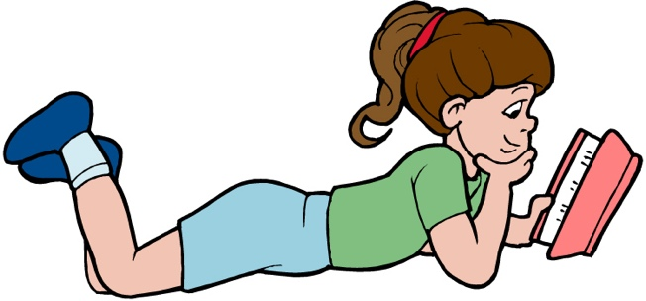 | 19. Understand books (and other texts) read independently, checking that text is meaningful and discuss what has been understood.  20. Identify significant ideas, events and characters and discuss their significance.  21. Raise queries about texts and ask questions to improve understanding.  22. Participate in discussions about books (and other texts) that are read to them and those they can read for themselves.  23. Explain a personal point of view, giving reasons for their view.  24. Recommend books (and other texts) to peers, giving reasons for their choices.  25. Identify the effect of the context on a text (eg historical or other cultures).  26. Make connections and comparisons between different versions of the same text, other texts, prior knowledge and experience.  27. Explain and discuss their understanding of what they have read, including through formal presentations and debates, maintaining a focus on the topic and using notes where necessary.  28. Identify and discuss themes and conventions in and across a wide range of writing.
Retrieve | Range
8. Use scanning to find and identify key information.  9. Retrieve, record and present information from more than one source of non-fiction (eg when carrying out research). | 29. Read for a range of purposes, discussing an increasingly wide range of fiction, poetry, plays, non-fiction and reference books or textbooks.  30. Increase familiarity with a range of books from our literary heritage and books from other cultures and traditions.  31. Read aloud and perform poems and plays, showing understanding through intonation, tone, volume and action.  32. Learn poems by heart eg narrative verse, haiku.
Interpret | Vocabulary
10. Summarise the main points / ideas drawn from a text (more than one paragraph), identifying key details that support the main ideas, orally and in writing.  11. Distinguish between statements of fact and opinion.  12. Draw inferences such as inferring characters' feelings, thoughts and motives from their actions.  13. Justify inferences with evidence from the text.  14. Make predictions from details stated and implied information.  15. Present the author’s viewpoint of a text. | 33. Explore the meaning of increasingly complex words in context, eg by using meaning-seeking strategies.  34. Use meaning – seeking strategies to explore the meaning of idiomatic and figurative language.
Choice | Writing
16. Read non-fiction texts and identify purpose, presentation and structures and evaluate how effective they are (eg how much they contribute to the meaning of a text).  17. Identify purpose and comment on word choice and grammatical features of a text.  18. Discuss and comment on the writer’s use of language for effect, including figurative language, considering impact (eg precisely chosen adjectives, similes and personification). | 35. Read non-fiction texts and identify purpose, presentation and structures and evaluate how effective they are eg how much they contribute to the meaning of a text.  36. Use knowledge of structure of text type to find key information.  37. Read books (and other texts) that are structured in different ways.  38. Identify formal and informal language.

Age-related expectations: Reading, Year 6

Fluency | Explore and evaluate
- Can fluently read a set text appropriate for their age.  - Apply phonic knowledge and skills to read unfamiliar words.  - Apply knowledge of root words, prefixes and suffixes (see National Curriculum, Appendix 1, Y5,6 list) to read aloud (attempting pronunciation) and to understand the meaning of unfamiliar words.  - Use combined knowledge of phonemes and word derivations to pronounce words correctly (eg arachnophobia, audience)  - Read fluently, using punctuation to inform meaning.  - Apply knowledge of morphology and etymology to read and understand words.  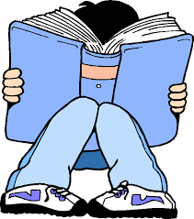  - Read further exception words, noting the unusual correspondences between spelling and sound, and where these occur in the word. | 17. Understand books (and other texts) read independently, ensuring that the book is meaningful and discuss what has been understood.  18. Explain the main purpose of a text.  19. Raise queries about texts to extend understanding.  20. Explain and comment on explicit and implicit points of view.  21. Express a personal point of view about a text (eg about organisation, presentation, writers’ choice), giving reasons linked to evidence from texts.  22. Build on or present counter-arguments to others’ ideas and opinions about a text in discussion.  23. Recommend books (and other texts) to peers, giving reasons for their choices.  24. Compare and contrast books (and other texts): within and across texts (including by different authors who may have different views and comparison of different versions).  25. Identify and explain the effect of the context on a text (eg historical or geographical).  26. Make connections between reading and prior knowledge and experience; explain the links.  27. Explain and discuss their understanding of what they have read, including through formal presentations and debates, maintaining a focus on the topic and using notes where necessary.
Retrieve | Range
8. Retrieve relevant information by skimming and scanning, taking notes / highlighting to record key points. | 28. Read books (and other texts) that are structured in different ways.  29. Read and discuss non-fiction texts (eg to support other curriculum areas).  30. Read and discuss a range of texts, including myths, legends and traditional stories, modern fiction, fiction from our literary heritage and books from other cultures and traditions.  31. Read aloud and perform poems and plays, showing understanding through intonation, tone, volume and action.  32. Learn poems by heart eg narrative verse, sonnet.
Interpret | Vocabulary
9. Summarise the main ideas drawn from a text (more than one paragraph), identifying key details that support the main ideas.  10. Distinguish between statements of fact and opinion.  11. Draw inferences (eg inferring characters' feelings, thoughts and motives from their actions).  12. Develop explanations to justify inferences using evidence from the text.  13. Predict what might happen from details stated and implied from across a text.  14. Present and explain the author’s viewpoint in a text.  15. Present an oral overview or summary of a text. | 33. Explore the meaning of increasingly complex unfamiliar words in context, eg by using meaning-seeking strategies.  34. Explore meanings of idiomatic and figurative language (eg by using meaning-seeking strategies).
Choice | Writing
16. Identify, comment (with consideration of impact) and back up views on how the following contribute to the meaning and effectiveness of a text:  - language, structure and presentation (eg is it clear, attractive, easy to fact-find?)  - writer’s choice of vocabulary  - writer’s craft, including figurative language, grammatical features, text structure (eg the use of short sentences to build tension) | 35. Collate and organise information / points / evidence appropriately.  36. Recognise texts that contain features from more than one text type.  37. Identify and discuss the conventions of different text types.  38. Identify formal and informal language.

